RESOLUTION NO.__________

RE: CERTIFICATE OF APPROPRIATENESS UNDER THE
PROVISIONS OF THE ACT OF THE PENNSYLVANIA
LEGISLATURE 1961, JUNE 13, P.L. 282 (53
SECTION 8004) AND BETHLEHEM ORDINANCE NO.
3952 AS AMENDED.

WHEREAS, it is proposed to remove existing porch columns, porch floor deck board, railings skirt boards etc. at 30 E. Market St.

NOW, THEREFORE, BE IT RESOLVED by the Council of the City of Bethlehem that a Certificate of Appropriateness is hereby granted for the proposal.

Sponsored by: (s)

(s)

ADOPTED BY COUNCIL THIS DAY OF

(s)
President of Council

ATTEST:

(s)
City Clerk

HISTORICAL & ARCHITECTURAL REVIEW BOARD

The applicant proposes to remove and replace the existing porch columns, porch floor deck board, railings, skirt boards etc. at 30 E. Market St.
APPLICATION #4:

Joe Sullivan
30 E. Market St.
Bethlehem, PA 18018

OWNER:

__________________________________________________________________

The Board upon motion by Phil Roeder and seconded by Nancy Shelly adopted the proposal that City Council issue a Certificate of Appropriateness for the following:

- Remove existing 5/4” x 6” pressure treated porch decking and replace with
1” x 4” tongue and grooved fir decking.

- The applicant will prime paint the new work to seal it for the winder and return to
HARB for review and paint color approval.

3. Repair porch columns, railings, skirt boards, trim and mouldings.

4. The motion was unanimously approved.

__________________________________________________________________________

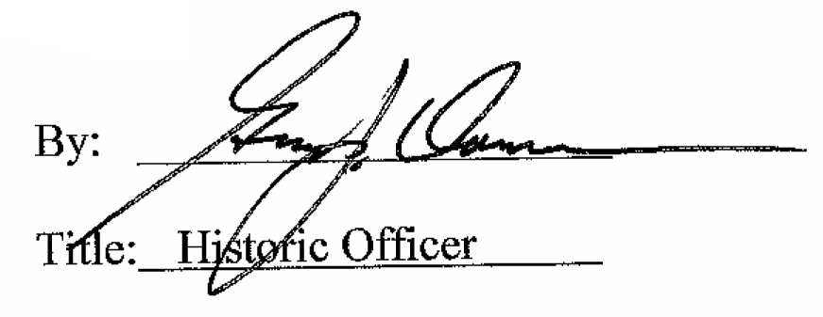

Date of Meeting: October 7, 2015

